|  |
| --- |
| **GTSS Operational Risk** |
| **ORX** |
| **Business Requirements Document** |
| **Version: 0.1** |

##### Document Version Control

The revision history should contain details of all changes made to this document. No old entries may be amended in any way. Each new version of the document must contain all history of all previous versions.

| Ver. | Date | Author | Comment/Summary of Updates |
| --- | --- | --- | --- |
| 0.1 | 23/11/2016 | SHassen | Draft |
|  |  |  |  |
|  |  |  |  |

Peer Review

|  |  |  |
| --- | --- | --- |
| Name | Designation | Date |
| Emily Mataitsane |  |  |
| Karel Du Plessis |  |  |
| Faizel Mohideen |  |  |

Document Signoff

All parties involved acknowledge that they have read, understood and agree with all the requirements as specified in this document.

| Name | Area | Signature | Date |
| --- | --- | --- | --- |
|  |  |  |  |
|  |  |  |  |
|  |  |  |  |
|  |  |  |  |
|  |  |  |  |
|  |  |  |  |
|  |  |  |  |
|  |  |  |  |
|  |  |  |  |
|  |  |  |  |

Distribution List

| Name | Designation | Area |
| --- | --- | --- |
|  |  |  |
|  |  |  |
|  |  |  |
|  |  |  |
|  |  |  |
|  |  |  |

##### Table of Contents

1 Executive Summary 4

1.1 Background 4

1.2 Problem Statement 4

1.3 Purpose 4

2 Business Requirement 5

2.1 Current (As is) 5

ORX Global 5

ORX Report SA 5

2.2 Functional Requirement 6

3 Business Opportunities (Benefit) 7

3.1 Constraints 7

# Executive Summary

## Background

The Committee wants to enhance operational risk assessment efforts by encouraging the industry to develop methodologies and collect data related to managing operational risk. Consequently, the scope of the framework focuses primarily upon the operational risk component of other risks and encourages the industry to further develop techniques for measuring, monitoring and mitigating operational risk.

In framing the current proposals, the Committee has adopted a common industry definition of

Operational risk, namely;

The risk of direct or indirect loss resulting from inadequate or failed internal processes, people and systems or from external events.

## Problem Statement

The current ORX reports on the QlikView does not cater for the requirements to submit data to the consortium.  Manual work is required to get the data mapped to ORX taxonomies for submission.  The current reports needs to be updated and mapped to the ORX taxonomies outside the ARM system.

## Purpose

This document will detail the Business Requirement only.

* ADM Event Type ID to be mapped to ORX as supplied by business.
* Mapping of Business lines to be in line with ORX.

# Business Requirement

1. Add an extra field to the report called ORX Alignment.
2. Report to lookup Event Types and display the ORX data mapping

## Current (As is)

The current as is process is to run the reports.  Send to business to confirm. Do excel enhancements to the data to map to the ORX data taxonomy and submit it to ORX.

**Report in Qlikview**

## ORX Global

|  |  |
| --- | --- |
| Business Line > COR > ORX Report - Global | |
| Purpose | |
| Displays (for external reporting) individual incidents with a Gross Loss greater than the threshold of EUR20,000; and the relevant required detail, for a given selection of:   * Organisational unit (event) * Reporting year and month * Effect year and month * Record status of event and/or effect | |
|  |  |
| Instructions | |
| 1. Select the Event Organisational Unit and/or 2. Select the Reporting Year and Reporting Month to extract data for the necessary period 3. Select the current effect period i.e. current year or current quarter (whilst ignoring the reporting date filter) to determine if ‘older’ incidents have experienced a movement in loss value. 4. Select valid Event and Effects Record states | |
| ORX Report SA Business Line > COR > ORX Report SA  Purpose | |
| Displays (for external reporting) individual incidents with a Gross Loss greater than the threshold of ZAR50,000; and the relevant required detail, for a given selection of:   * Organisational unit (event) * Reporting year and month * Effect year and month * Record status of event and/or effect | |
|  | |

|  |
| --- |
| Instructions |
| 1. Select the Event Organisational Unit and/or 2. Select the Reporting Year and Reporting Month to extract data for the necessary period 3. Select the current effect period i.e. current year or current quarter (whilst ignoring the reporting date filter) to determine if ‘older’ incidents have experienced a movement in loss value. 4. Select valid Event and Effects Record states |

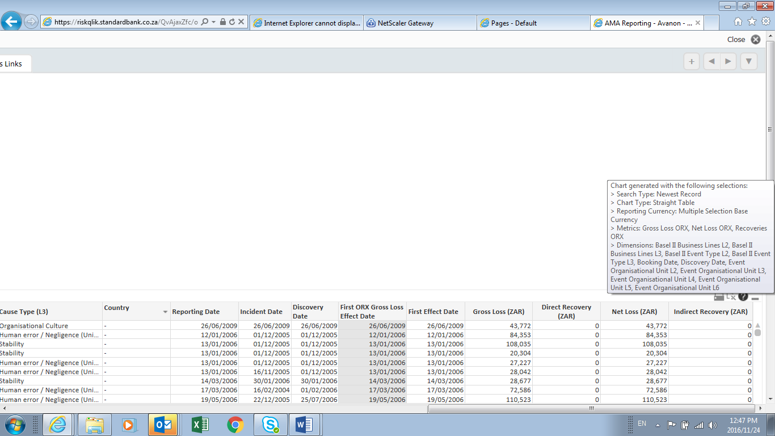

## Functional Requirement

#### The report must include the following field

ORX Alignment

# Business Opportunities (Benefit)

Less or no manual work required which will result in quicker turnaround times.

## Constraints

The data consortium submission is on a Quarterly basis when the consortium advises SBSA of the submission dates. In general, the submission is end of January, April, July and October. Confirm with business on this dates